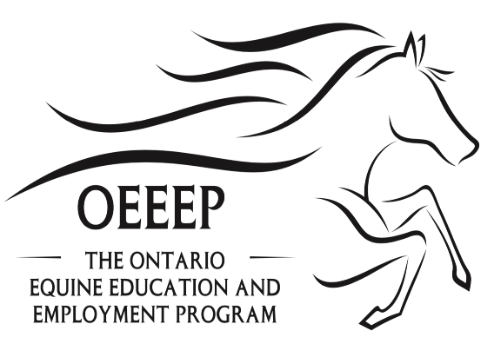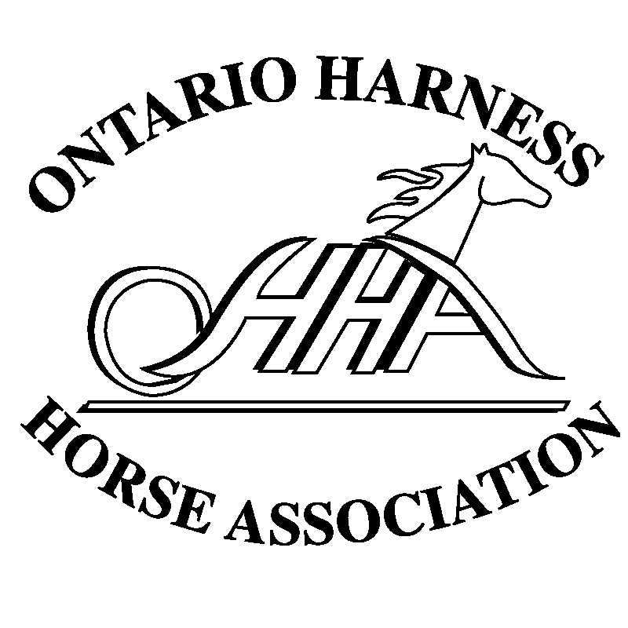
Barn Rules for Staff and Visitors to Reduce the Risk of Medication Contamination in Horses Competing in a Regulated Industry
- Absolutely no urinating or spitting in stalls. Adequate washrooms should be provided.
- Prevent horses, their feed, supplements, or equipment from contacting human medications or supplements.
- Avoid bringing human medications into the barn area.
- Wash hands immediately after touching or taking medications, and before touching a horse or associated equipment, or wear gloves and dispose of them after taking medication.
- Wash hands after eating and or drinking.
- Use delegated staff to administer equine medications.
- Do not feed horses any treats or supplements unless approved by barn manager or trainer-of-record.
- Wash feed tubs and water pails from horses that have received oral medication.
- Ensure that horses are not moved to different stalls without inspecting and cleaning the new stall as required.
- Do not turn out horses receiving medications with a horse preparing to compete without prior approval from the barn manager or trainer-of-record.
- Do not re-use needles or syringes and thoroughly clean IV tubing.
- Provide each horse with their own oral syringe.
- Discuss with the barn manager or trainer-of-record any concerns about a source of potential drug contamination.

